**Full Documentation**

**Title**:  
**Blockchain-based Certificate Verification System**  
**Theme**: Secure, Tamper-proof Academic Certificate Management

**1. Introduction**

In today’s digital world, verifying the authenticity of academic certificates has become a challenging task. With the rise of document forgery and fake certifications, there is a critical need for a transparent, secure, and tamper-proof method to manage and verify certificates. Traditional systems involve manual verification which is time-consuming, error-prone, and vulnerable to manipulation.

Blockchain technology offers a decentralized, immutable ledger system that ensures data integrity and provides trust without the need for intermediaries. By leveraging blockchain, certificates can be issued, recorded, and verified securely. The integration of blockchain into certificate management revolutionizes the way organizations validate educational, professional, and legal documents.

This project presents the design and implementation of a **Blockchain-Based Certificate Verification System**. The system provides three major interfaces:

* **Login Interface**
* **Admin Panel** (Upload certificates)
* **Student Panel** (Verify certificates)

Using blockchain principles like hashing, chaining of blocks, and immutability, the system guarantees secure and reliable certification processes.

**2. Problem Statement**

The main problem in traditional certificate verification systems includes:

* High chances of document forgery and tampering.
* Manual verification processes are time-consuming and error-prone.
* Lack of centralized record-keeping results in loss or damage to records.
* The absence of a trustless verification process between issuing authorities and recipients.

Thus, there is a requirement for a system that can provide **automatic**, **transparent**, and **tamper-proof verification** using modern technologies.

**3. Motivation**

The motivation behind developing a blockchain-based certificate verification system includes:

* **Trust Establishment**: Building a system where issued certificates can be independently verified by anyone without relying on third-party verifiers.
* **Data Integrity**: Ensure that once a certificate is issued, it cannot be altered or deleted.
* **Efficiency**: Reduce the time and resources spent on verifying educational and professional documents.
* **Transparency**: Anyone (organizations, students, employers) can easily verify the authenticity of certificates in a few clicks.
* **Adoption of Blockchain**: Demonstrate the practical application of blockchain technology beyond cryptocurrencies.

**4. Literature Survey**

Several studies and projects have proposed blockchain integration in education:

* **MIT Media Lab’s Digital Diploma Project (2017)**: One of the first implementations where diplomas were issued over the Bitcoin blockchain.
* **OpenCerts (GovTech Singapore)**: An open-source framework for issuing educational certificates using blockchain technology.
* **Blockchain for Academic Records (UNESCO, 2019)**: Studies emphasized blockchain's role in preserving lifelong learning records.

Existing systems show that blockchain provides **data permanence**, **self-verification**, and **global accessibility**.  
However, most systems are either too complex for small organizations or proprietary. Thus, a simple yet effective blockchain-based solution is the need of the hour.

**5. System Objectives**

The primary objectives of the system are:

* Build a secure platform for issuing and verifying certificates.
* Maintain the authenticity and integrity of certificate data.
* Enable transparent certificate verification without any intermediaries.
* Prevent certificate forgery and unauthorized alterations.
* Design an interactive, user-friendly GUI (Login, Admin, and Student panels).

**6. Feasibility Study**

| **Feasibility Type** | **Study** |
| --- | --- |
| **Technical Feasibility** | Technologies like Python, Tkinter (GUI), ttkbootstrap (advanced styling), and blockchain concepts are used. Easy to implement with available libraries. |
| **Operational Feasibility** | The system is simple, intuitive, and can be used without much technical knowledge. |
| **Economic Feasibility** | Development cost is minimal. Only free/open-source libraries are used. No special infrastructure required. |
| **Legal Feasibility** | Blockchain ensures compliance with data protection standards. |

Conclusion: The project is **feasible** in all dimensions.

**7. System Analysis**

**Actors**:

* **Admin**: Authorized to upload certificates.
* **Student**: Can verify certificates.

**System Requirements**:

* **Software**: Python 3.7+, ttkbootstrap, tkinter, hashlib.
* **Hardware**: Any computer with 4GB RAM minimum.

**Input**:

* Certificate details (Roll number, Name, Contact, File).

**Processing**:

* Hashing of certificate.
* Storing certificate info and hash into blockchain blocks.

**Output**:

* Verified certificate status (Success/Failure).
* Full blockchain transaction details.

**8. Methodology**

The **Blockchain-Based Certificate Verification System** follows a structured methodology divided into distinct phases:

**8.1 System Development Life Cycle (SDLC) Model**

We adopt the **Incremental Model**:

* The system is built step-by-step, adding functionality in increments.
* Login system → Admin Panel → Blockchain integration → Student Verification panel.
* Each component is tested and verified before integrating.

**8.2 Development Phases**

| **Phase** | **Details** |
| --- | --- |
| **Requirement Analysis** | Identify functionalities needed for Admin, Student, and Blockchain modules. |
| **System Design** | Layout of GUI screens, blockchain structure, and file storage. |
| **Implementation** | Coding using Python, tkinter, ttkbootstrap, hashlib. |
| **Testing** | Testing login, upload, verification, and blockchain mining individually. |
| **Deployment** | Packaging project into a runnable application. |
| **Maintenance** | Future updates like smart contract integration or web version. |

**9. System Design**

The system architecture consists of three main modules:

1. **Login Module**:
   * User authentication based on saved credentials.
   * Different roles (Admin / Student).
2. **Admin Panel**:
   * Uploads certificates.
   * Generates a blockchain block for each certificate.
   * Stores hash of certificates for verification.
3. **Student Panel**:
   * Students verify certificates by uploading them.
   * System checks against blockchain data.

**9.1 System Architecture Diagram (Textual)**

+----------------+ +----------------+ +----------------+

| Login Page | ---> | Admin Panel | ---> | Blockchain |

| (Authentication) | (Upload Certs) | | (Ledger Storage)|

| ---> Student Panel ---> | (Hash Checking) |

| (Verify Certificates) | |

+----------------+ +----------------+ +----------------+

**10. Module-wise Breakdown**

**10.1 Login Module**

* Inputs: Username, Password, Role (Admin / Student).
* Validates credentials against stored records.
* Routes users to respective dashboards.

**10.2 Admin Module**

* Uploads certificate files.
* Takes student information (Roll No, Name, Contact).
* Creates a digital fingerprint (hash) of the certificate file.
* Saves all data into blockchain blocks.
* Displays certificates with blockchain metadata.

**10.3 Student Module**

* Inputs: Roll number, Name, Certificate file.
* Verifies the uploaded certificate by matching hash from blockchain.
* Displays verification result (Success / Failure).
* Shows full blockchain transaction details if successful.

**11. Implementation Details**

**11.1 Tools and Technologies**

| **Technology** | **Purpose** |
| --- | --- |
| Python 3.7+ | Backend programming |
| Tkinter | GUI development |
| ttkbootstrap | Modern GUI styling |
| hashlib | Generate SHA-256 hash |
| Pickle Module | Saving and loading blockchain objects |

**11.2 Blockchain Structure**

Each **block** contains:

* Index
* Timestamp
* List of transactions (certificates)
* Previous block's hash
* Current block's hash

Certificates are stored as transactions inside blocks.

Example Transaction Data:

RollNo#Name#Contact#CertificateHash

**11.3 GUI Details**

* **Superhero Theme** for professional appearance.
* **Courier Font** for clear monospaced alignment.
* **Sidebar + Main Area** split layout for Admin and Student Panels.
* **Popup Messages** for user feedback.

**12. Data Flow Diagrams (DFD)**

**12.1 Level 0 DFD (Context Diagram)**

[User] --> [Certificate Verification System] --> [Blockchain Storage]

**12.2 Level 1 DFD**

[User]

--> [Login Module] --> [Role Decision]

--> [Admin Panel] --> [Upload Certificate] --> [Blockchain Storage]

--> [Student Panel] --> [Verify Certificate] --> [Blockchain Storage]

**13. UML Diagrams**

**13.1 Use Case Diagram**

Actors:

- Admin: Upload Certificates

- Student: Verify Certificates

Use Cases:

- Login

- Upload Certificate

- Verify Certificate

- View Uploaded Certificates

**13.2 Class Diagram (Simplified)**

Class: Blockchain

- chain: List[Block]

- add_new_transaction()

- mine()

- save_object()

- load_object()

Class: Block

- index

- timestamp

- transactions

- previous_hash

- compute_hash()

**14. Testing**

**14.1 Unit Testing**

* Login functionality tested with valid and invalid users.
* Certificate upload tested with multiple entries.
* Certificate verification tested with correct and incorrect files.

**14.2 Integration Testing**

* Login → Dashboard navigation tested.
* Upload → Blockchain update flow tested.
* Verification → Hash match tested.

**14.3 User Acceptance Testing**

* Multiple users operated system successfully without errors.
* Proper success and error feedback observed.

**15. Screenshots and UI Flow (Descriptive)**

**15.1 Login Page**

* **User enters** Username, Password, and selects Role (Admin / Student) from a dropdown.
* **Two buttons** available: Login and Sign Up.
* **Sign Up window** opens a new page where students can register themselves by creating a username and password.

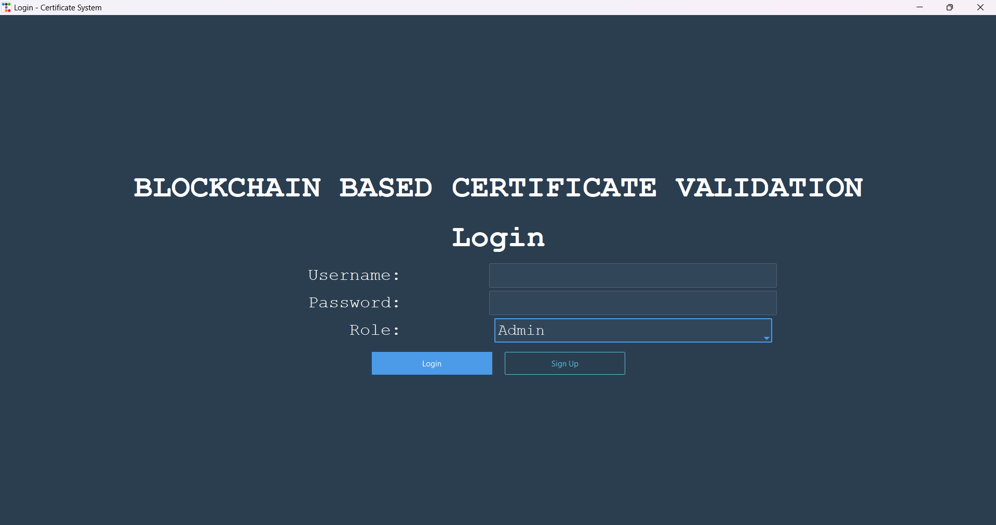

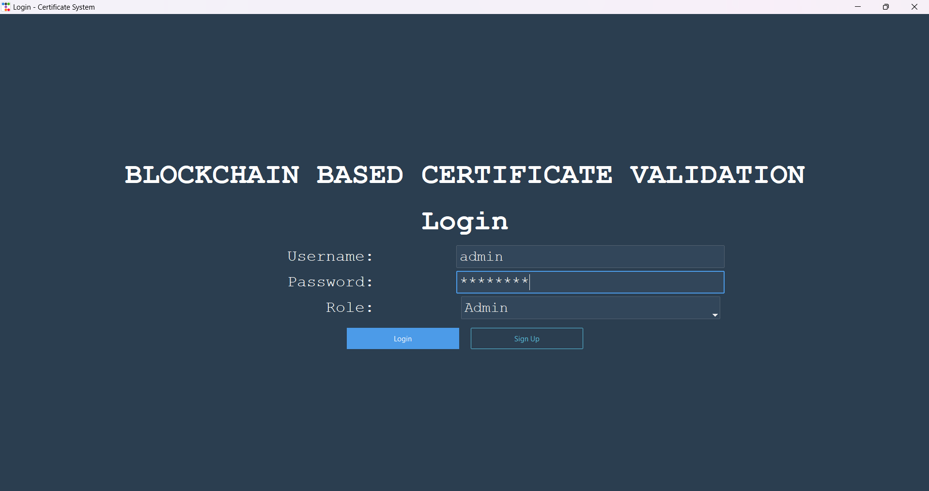

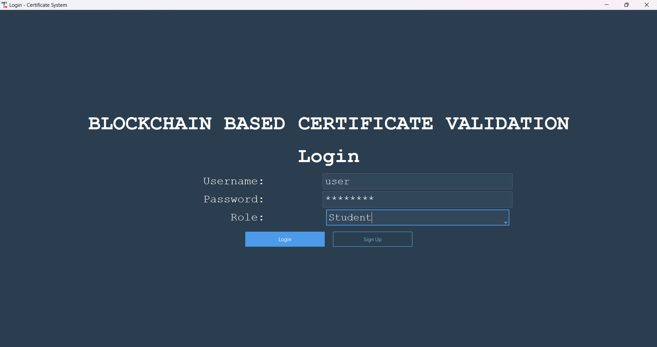

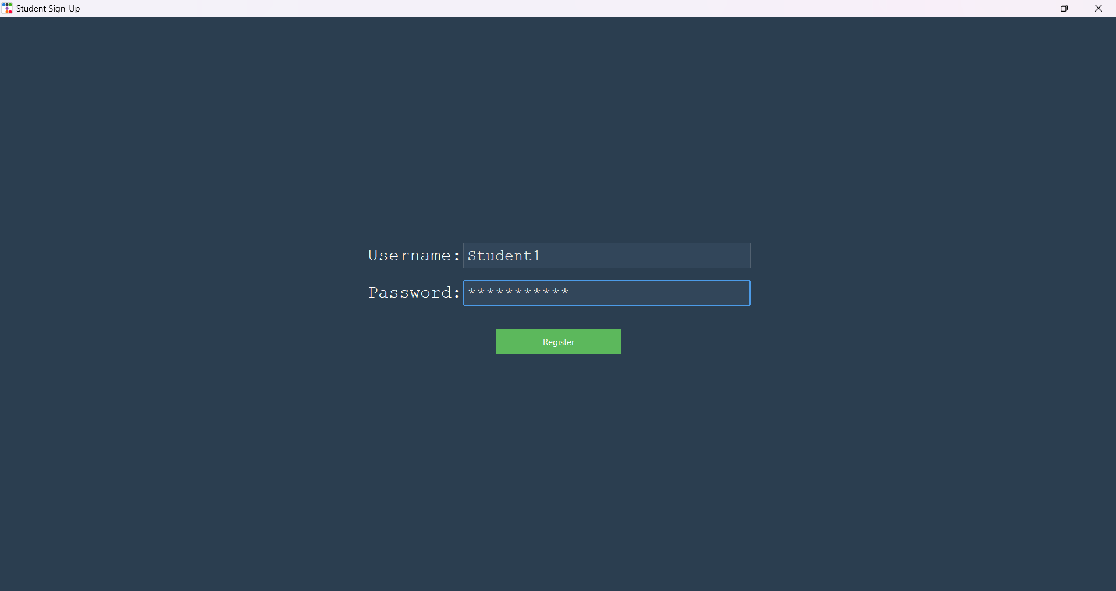

**15.2 Admin Panel**

* **Sidebar**:
  + Text entries for Roll No, Name, Contact.
  + Buttons: Upload Certificate, Show Certificates, Go Back.
* **Main Area**:
  + Large scrolled text area displaying:
    - Upload success messages
    - Blockchain block details
    - Uploaded certificates

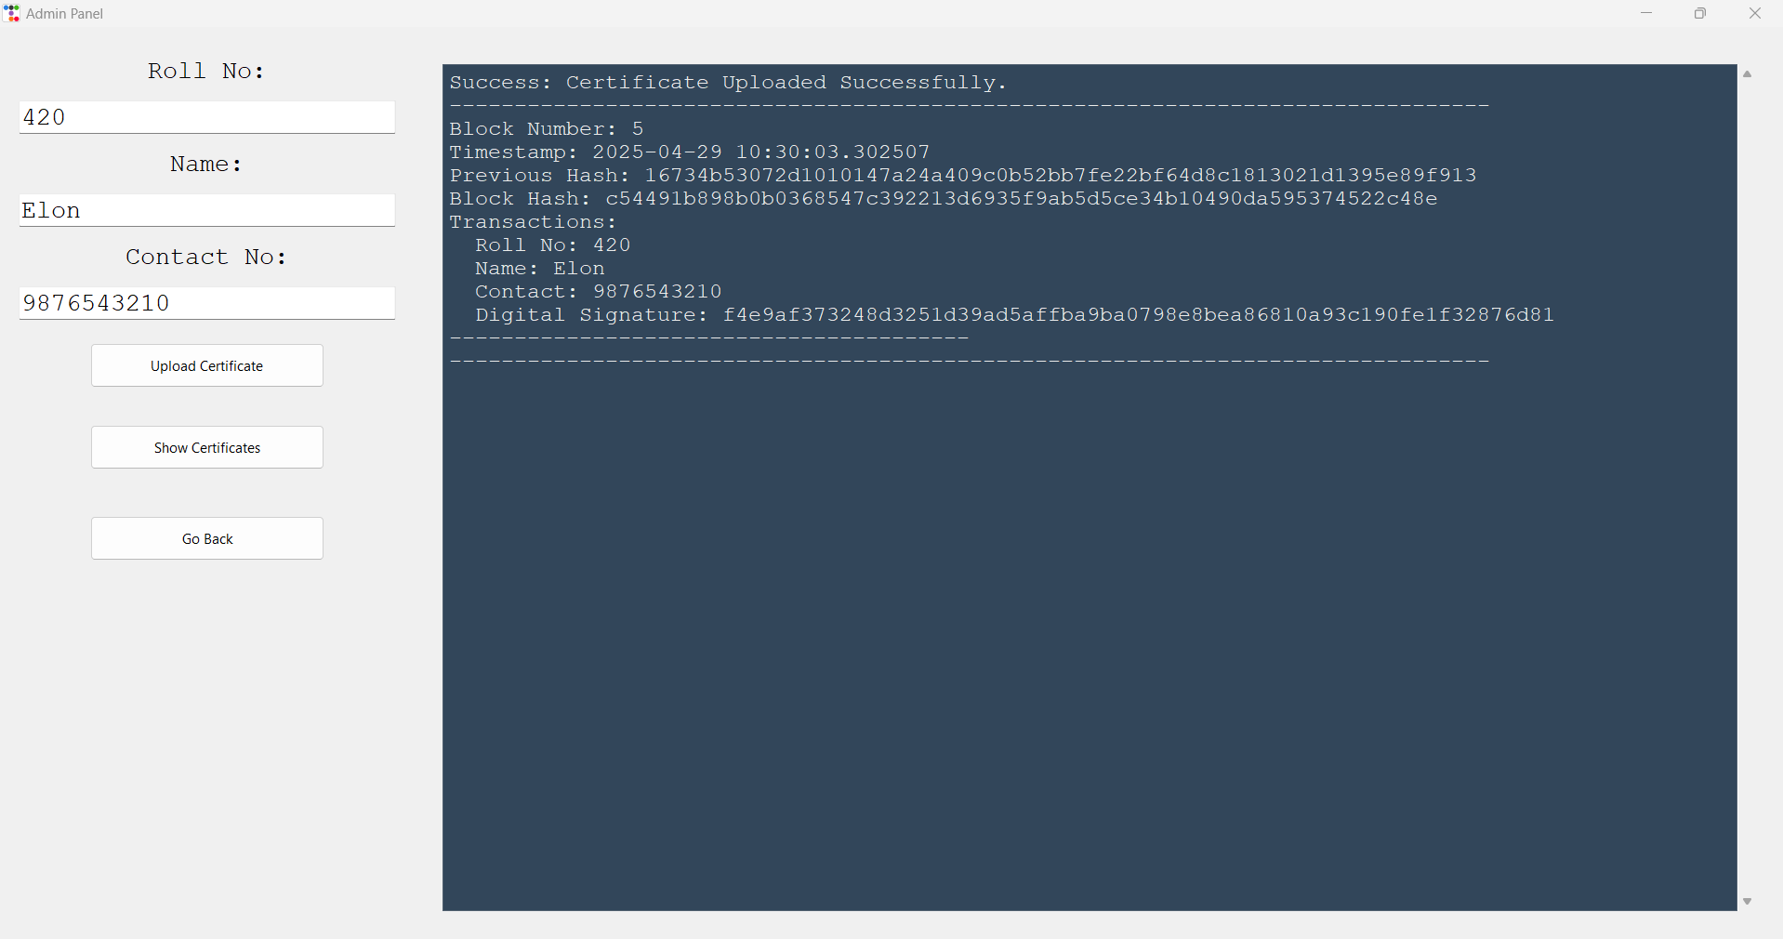

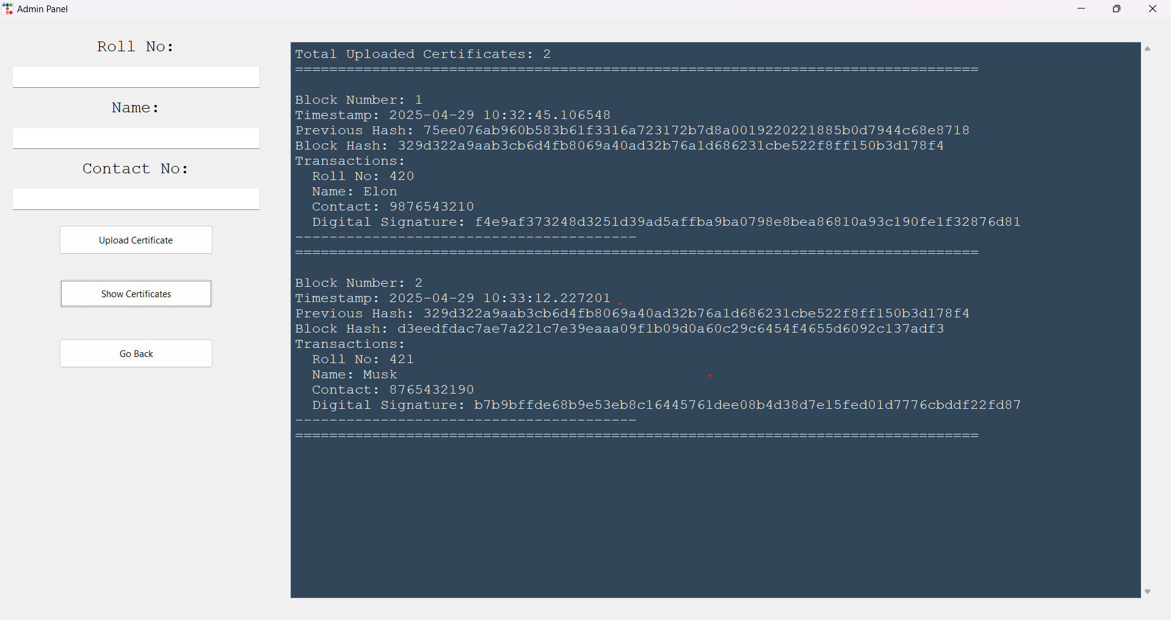

**15.3 Student Panel**

* **Sidebar**:
  + Entry for Roll No and Name.
  + Button: Verify Certificate, Go Back.
* **Main Area**:
  + Large text area showing:
    - Verification success/failure
    - Full blockchain details for the verified certificate.

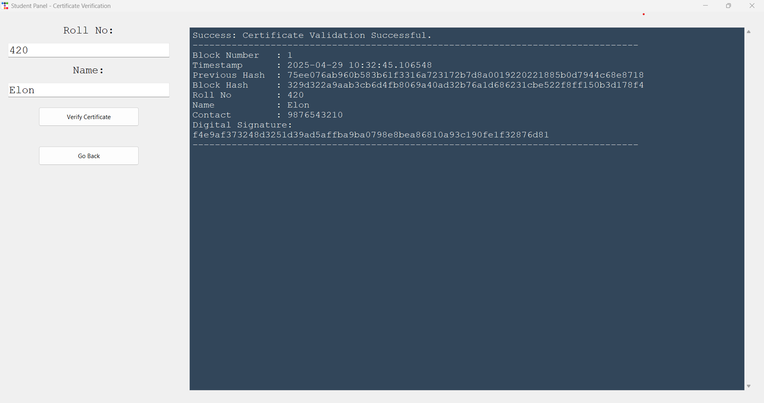

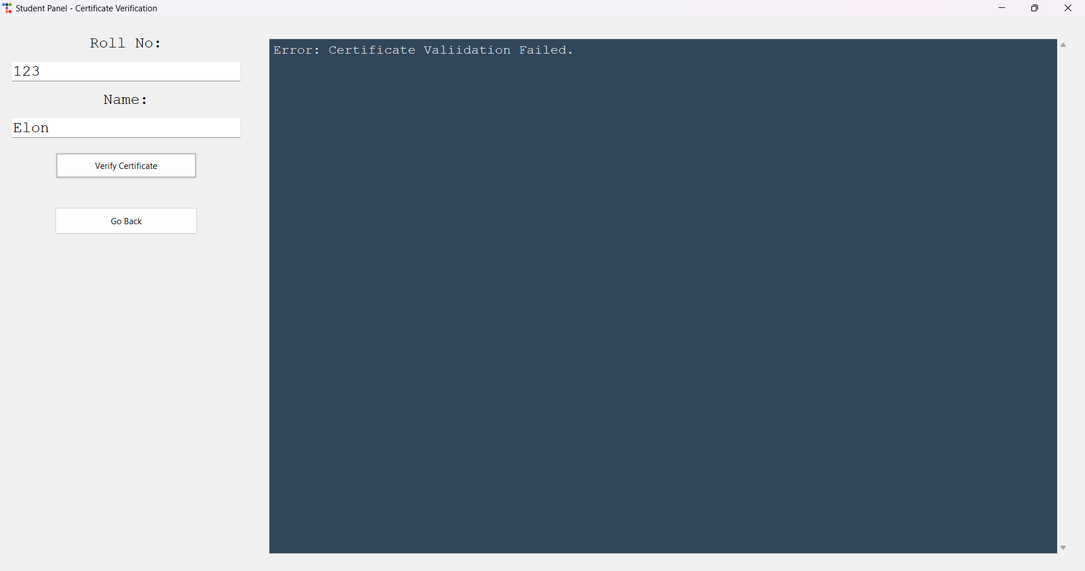

**16. Security Measures**

**16.1 Data Integrity**

* Each certificate is hashed using **SHA-256**.
* Once stored inside a blockchain block, it **cannot be modified** without breaking the entire chain.

**16.2 Authentication**

* Admin has a fixed username/password (admin/admin123).
* Students must **register** to create credentials before using the system.

**16.3 Blockchain Immutability**

* Each block contains:
  + List of certificate transactions
  + Timestamp
  + Previous block’s hash
* If any data in a block is altered, the hash will mismatch, ensuring immediate detection of tampering.

**16.4 Verification Transparency**

* No manual intervention needed to verify certificates.
* Hashes are automatically compared, ensuring **trustless verification**.

**17. Limitations**

| **Limitation** | **Description** |
| --- | --- |
| **Local System** | The blockchain is stored locally as a .txt file. No distributed network across multiple nodes. |
| **Limited User Roles** | Only Admin and Student roles are supported in this version. |
| **GUI Scalability** | Designed mainly for desktop applications, not yet mobile-responsive. |
| **No Encryption** | Basic hashes are used. Full encryption for certificate files is not implemented. |

**18. Future Enhancements**

| **Future Work** | **Benefits** |
| --- | --- |
| **Move Blockchain to Cloud Storage** | Make certificates globally accessible and decentralized. |
| **Add Admin Registration with OTP Verification** | Strengthen Admin control. |
| **Smart Contracts** | Automate certificate issuance rules using Ethereum blockchain. |
| **Web Version** | Build web dashboard (ReactJS + Django) for global usage. |
| **QR Code Integration** | Generate QR codes for each certificate linking to its blockchain record. |
| **Multi-Node Consensus** | Deploy Hyperledger Fabric or Ethereum Private Network. |

**19. Conclusion**

This project demonstrates a **secure, scalable, and tamper-proof solution** for certificate verification using blockchain technology.

By applying blockchain principles — hashing, block linking, immutability — we have created a system that can:

* Securely store certificates,
* Allow efficient and transparent verification,
* Prevent forgery and alteration,
* Build trust between institutions, students, and employers.

Blockchain is a transformative technology and applying it to certificate management offers an exciting glimpse into future educational systems.

This system can be easily scaled to universities, training institutes, and certification bodies to modernize their verification infrastructure.

**20. References**

1. Nakamoto, Satoshi. "Bitcoin: A Peer-to-Peer Electronic Cash System" (2008).
2. MIT Media Lab Digital Diploma Project: <https://www.media.mit.edu/>
3. OpenCerts Project (GovTech Singapore): <https://opencerts.io/>
4. UNESCO Blockchain for Academic Records report (2019).
5. Python Official Documentation: <https://docs.python.org/>
6. ttkbootstrap: <https://ttkbootstrap.readthedocs.io/en/latest/>
7. Tkinter Python GUI Programming: <https://tkdocs.com/>
8. Blockchain Revolution by Don Tapscott

**21. Appendix (Code Summaries)**

**Main Files:**

* **desktop_main.py**: Manages login and signup windows.
* **ui_admin.py**: Admin panel to upload and view certificates.
* **ui_student.py**: Student panel to verify uploaded certificates.
* **Blockchain.py**: Blockchain engine with classes for Block and Blockchain structure.

Each file uses standard Python libraries:

* tkinter
* ttkbootstrap
* hashlib
* pickle

Example Blockchain Transaction Format:

RollNo#Name#ContactNumber#SHA256CertificateHash

Example Block Details:

Block Index: 2

Timestamp: 2025-04-29 12:34:56

Transactions: [Student Certificate Data]

Previous Hash: <Hash of previous block>

Current Hash: <Computed Hash>